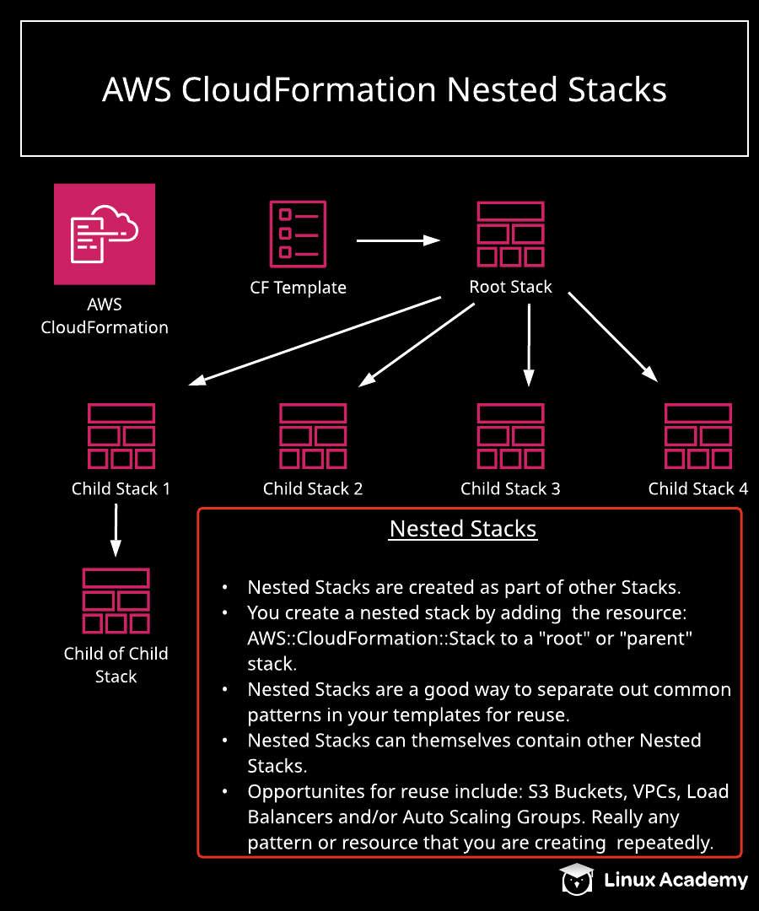

Working with CloudFormation Nested Stacks

Introduction
In this hands-on lab, we will create a nested stack from the templates provided. We will use the two templates to create a nested stack that will implement a child template, which will then create an S3 bucket with a policy of no retain. This child template can be reused repeatedly whenever an S3 bucket of this type is needed.

Solution
Log in with the credentials provided, and make sure you are in the us-east-1 (N. Virginia) region.
Download the necessary files from the lab's GitHub repository.

Create an S3 Bucket and Upload a CloudFormation Template to It
- Navigate to S3
- Click + Create bucket.
- On the Name and region screen, give your bucket a unique name. (Note: It must be all lowercase letters and be unique across all AWS accounts.) Click Next.
- Accept the default settings on the next screens, and click Create bucket.
- Click to open the bucket, and click Upload.
- Click Add files, and select the s3static.json CloudFormation template you downloaded earlier.
- Accept the default settings on the next screens, and click Upload.
- Click Upload.
- Click Add files, and select the noretain.json CloudFormation template you downloaded earlier.
- Accept the default settings on the next screens, and click Upload.

Create a Nested Stack from the CloudFormation Root Template
- In a new browser tab, navigate to CloudFormation.
- Click Create stack.
- In the Prerequisite - Prepare template section, select Create template in Designer.
- Click Create template in designer.
- Click the Template tab at the bottom.
- Paste the following (the root.json template included in the lab GitHub) into the Template window:
{
"AWSTemplateFormatVersion" : "2010-09-09",
"Resources" : {
"myStack" : {
"Type" : "AWS::CloudFormation::Stack",
"Properties" : {
"TemplateURL" : "https://s3.amazonaws.com/<YOUR-BUCKET-NAME>/noretain.json",
"TimeoutInMinutes" : "60"
}
}
}
}
- In the "TemplateURL" line, replace <YOUR-BUCKET-NAME> with the name of the bucket you just created.
- Click the checkbox at the top to validate the template, and then click the cloud icon with the up arrow to create the stack.
- Click Next.
- On the stack details page, give it a Stack name of s3webnoretain.
- Click Next.
- Leave the settings on the stack options page, and click Next.
- Check the boxes to accept the acknowledgements, and click Create stack. It will take a few minutes for it to fully be created.

Delete Root Stack
- Once it's deleted, click around to view its resource and events.
- Click to Delete the stack to see what happens.
- In the confirmation dialog, click Delete stack.
- Once it's finished deleting, both the root and nested stack should be gone.
- In the S3 browser tab, check to see that one of our S3 buckets is now gone.

Create a Nested Stack with Multiple Child Stacks
- In the CloudFormation browser tab, click Create stack.
- In the Prerequisite - Prepare template section, select Create template in Designer.
- Click Create template in designer.
- Click the Template tab at the bottom.
- Paste the following (the multinest.json template included in the lab GitHub) into the Template window:
{
"AWSTemplateFormatVersion" : "2010-09-09",
"Resources" : {
"myStack" : {
"Type" : "AWS::CloudFormation::Stack",
"Properties" : {
"TemplateURL" : "https://s3.amazonaws.com/<YOUR-BUCKET-NAME>/s3static.json",
"TimeoutInMinutes" : "60"
}
},
"myStack2" : {
"Type" : "AWS::CloudFormation::Stack",
"Properties" : {
"TemplateURL" : "https://s3.amazonaws.com/<YOUR-BUCKET-NAME>/noretain.json",
"TimeoutInMinutes" : "60"
}
}
}
}
- In the "TemplateURL" lines, replace <YOUR-BUCKET-NAME> with the name of your bucket.
- Click the checkbox at the top to validate the template, and then click the cloud icon with the up arrow to create the stack.
- Click Next.
- On the stack details page, give it a Stack name of twochildrenstacks.
- Click Next.
- Leave the settings on the stack options page, and click Next.
- Check the boxes to accept the acknowledgements, and click Create stack. It will take a few minutes for it to fully be created.

Upload an index.html File and Browse to It
- In the S3 browser tab, click to open one of the nested stack buckets.
- Click Upload.
- Click Add files, and select the index.html file included in the lab GitHub repository.
- Accept the default settings on the next screens, and click Upload.
- Click Upload.
- In the CloudFormation browser tab, select the nested stack in which you uploaded the index.html file.
- Click the Outputs tab, and browse to the listed WebsiteURL. It should display an Elastic Beanstalk web page, which is fine — all that matters is if it shows up alright.

Conclusion
Congratulations on successfully completing this hands-on lab!

